DOG RECORD
Member Name
Address
Contact Number
Member Prefix
DOGS NSW Membership Number
Registered Name
Microchip No. |  | Sex
Registration No. |  | Breed
Date of Birth | / / | Colour

BIRTH HISTORY OF WHOLE LITTER
Number of live females in the litter
Number of stillborn females in the litter
Number of females that died post-whelping
Number of live males in the litter
Number of stillborn males in the litter
Number of males that died post-whelping
Describe any birth complications

Purpose of Dog |  Exhibition  Companion  Breeding  (any discipline)

DOGS NSW Code of Practice-Record Keeping Information Booklet Dog Record
Issued December 2019 (Amended January 2021)

NEW OWNER DETAILS
Name
Residential address
Address where dog is housed
Contact Number
Microchip form transfer signed? | E Yes | E No | Microchip form transfer lodged? | E Yes | E No
Sales contract signed and given to new owner? | E Yes | E No

Note: Copy of microchip transfer form and signed contract/guarantee should be attached
DEATH/EUTHANASIA DETAILS
/ /
Date of euthanasia (or death)
Vet clinic performing euthanasia
Reason for euthanasia (death)
RETURN RECORD
Note: Copy of microchip transfer form must be attached
DOGS NSW Code of Practice-Record Keeping Information Booklet New Owner Details
Issued December 2019 (Amended January 2021)
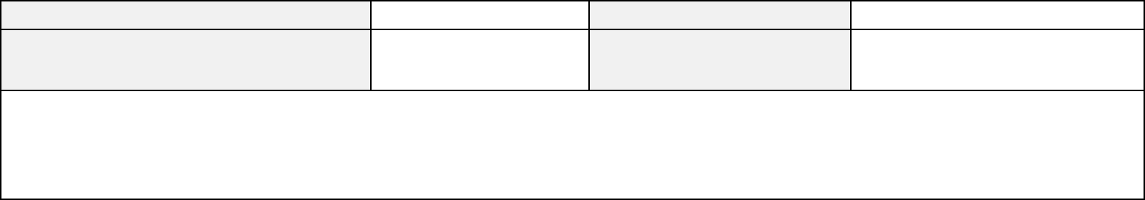
Microchip No.
Microchip form transfer signed?
Return reason
E Yes E No
Date: / /
Return date
Microchip form transfer lodged?
E Yes E No
Date: / /
/ /

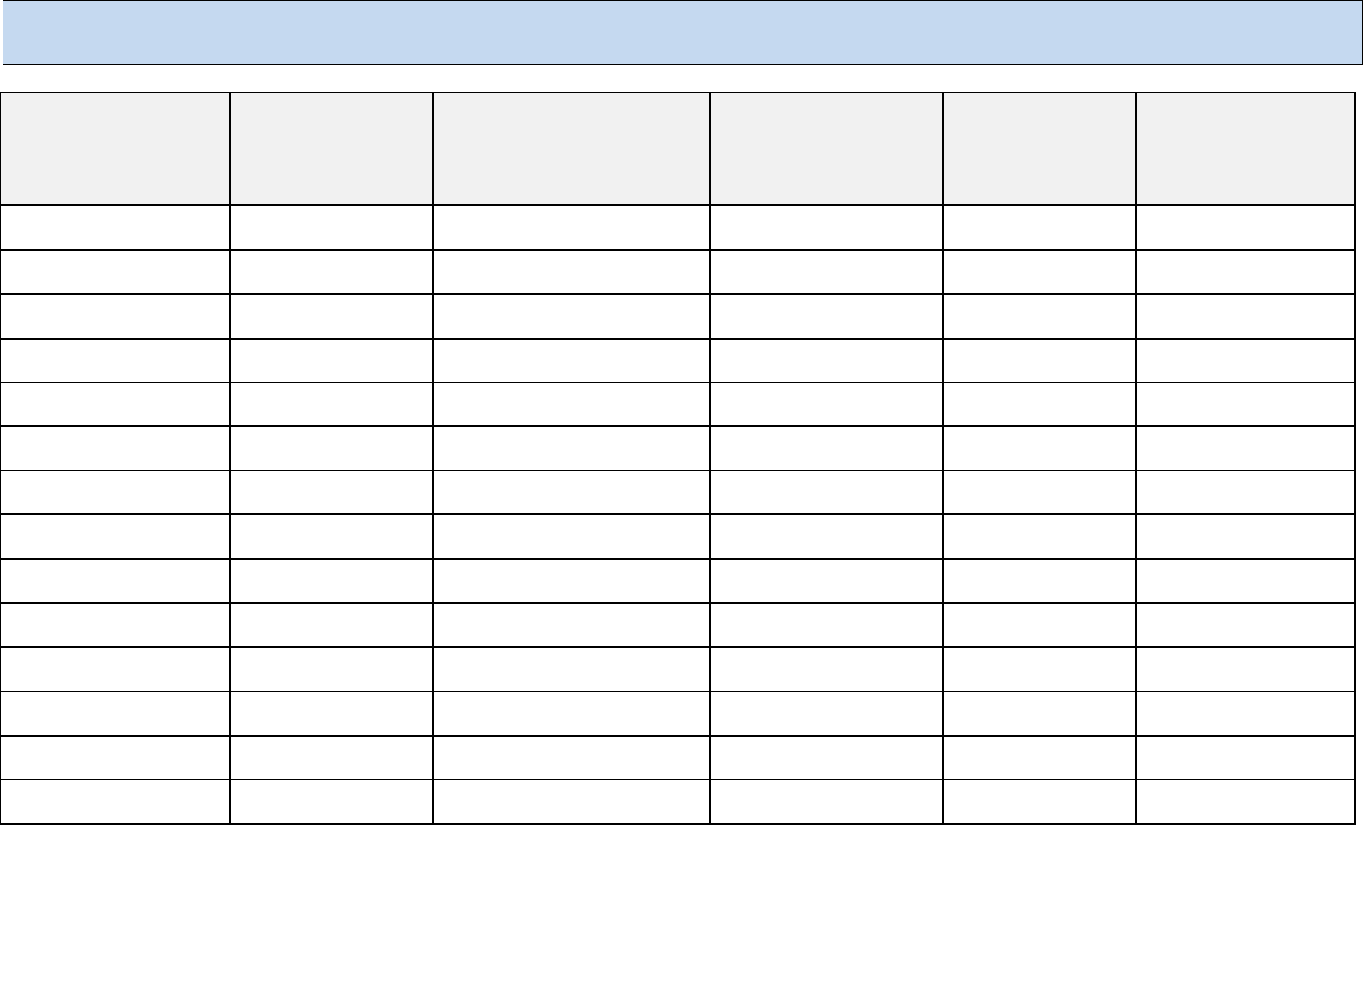
Heartworm
Core Vaccine - C3
(Distemper, Hepatitis,
Parvovirus)
Fleas, Ticks &
Mites
Date Given
Intestinal worms
Canine Cough
(parainfluenza (Type II) &
Bordetella bronchiseptica)
VACCINATION & WORMING HISTORY
(Must be accompanied by a copy of the veterinary issued vaccination record)
/ /
/ /
/ /
/ /
/ /
/ /
/ /
/ /
/ /
/ /
/ /
/ /
/ /
/ /
DOGS NSW Code of Practice-Record Keeping Information Booklet Vaccination & Worming Detail
Issued December 2019 (Amended January 2021)

GENERAL HISTORY
(Must be accompanied by a copy of any veterinary treatment record)
Date Given | Description of Illness/Injury | Treatment
/ /
/ /
/ /
/ /
/ /
/ /

DOGS NSW Code of Practice-Record Keeping Information Booklet General History
Issued December 2019 (Amended January 2021)

REPRODUCTIVE HISTORY (BITCH)
Registered Name
Microchip No. |  | Date of Birth | / /
Attach copy of breeding clearance to this record (if required/obtained)

Last annual health  certificate issue date | Mating/  Insemination  date  (List each  date) | Expected due  date | Sire  (Registered Name  Registered Number &  Microchip number) | Birth date | No. Live births  (Record colour/markings of each puppy) |  | No. Stillborn |  | Total  number  in Litter
 |  |  |  |  | Male | Female | Male | Femal  e | Total  number  in Litter
/ / |  | / / |  | / /
/ / |  | / / |  | / /
/ / |  | / / |  | / /
/ / |  | / / |  | / /
/ / |  | / / |  | / /
Attach copies of litter records whelped by this bitch here.
DOGS NSW Code of Practice-Record Keeping Information Booklet Reproductive History (Dog)
Issued December 2019 (Amended January 2021)

REPRODUCTIVE HISTORY (DOG)
Registered Name
Microchip No. |  | Date of Birth | / /
Attach copy of breeding clearance to this record

Last annual health  certificate issue date | Mating/  Insemination  date  (List each  date) | Expected due  date | Female  (Registered Name  Registered Number &  Microchip number) | Birth date | No. Live births  (Record colour/markings of each puppy) |  | No. Stillborn |  | Total  number  in Litter
 |  |  |  |  | Male | Female | Male | Femal  e | Total  number  in Litter
/ / |  | / / |  | / /
/ / |  | / / |  | / /
/ / |  | / / |  | / /
/ / |  | / / |  | / /
/ / |  | / / |  | / /
Attach file notes
DOGS NSW Code of Practice-Record Keeping Information Booklet Reproductive History (Dog)
Issued December 2019 (Amended January 2021)

LITTER RECORD

Member Name
Address
Contact Number
ANKC Breeding Prefix
DOGS NSW Membership Number

Breed

Litter Parents Details
Sire:
Registered Name
Microchip No. |  | Colour
Registration No. |  | Date of Birth | / /
Dam:
Registered Name
Microchip No. |  | Colour
Registration No. |  | Date of Birth | / /

1st Date of Season |  |  | Date of Insemination | / /
Method of Insemination  (AI - Circle applicable type) |  Natural |  Artificial Insemination Fresh Chilled Frozen (Surgical/TCI)  (circle applicable insemination type)
Comments and observations on bitch
during gestation
(Food, medications, health, etc)

DOGS NSW Code of Practice-Record Keeping Information Booklet Litter Record
Issued December 2019 (Amended January 2021)

WHELPING RECORD

Date first pup born: / /
Puppy  No. | Time | Sex | Colour | Markings | Placenta | Presentation | Weight | Comments
1
2
3
4
5
6
7
8
9
10

Litter Details
Number of females in the litter |  | Number of males in the litter
Number of live births in the litter |  | Number of stillborns in the litter
Describe any birth complications
DOGS NSW Code of Practice-Record Keeping Information Booklet Whelping Record
Issued December 2019 (Amended January 2021)

LITTER WEIGHT RECORD

Puppy ID | Birth | Day 1 | Day 2 | Day 3 | Day 4 | Day 5 | Day 6 | Day 7 | Day 8 | Day 9 | Day 10 | Day 11 | Day 12 | Day 13
1
2
3
4
5
6
7
8
9
10

Comments (progress of puppies plus dam; include full details of meals and fluids for dam)
DOGS NSW Code of Practice-Record Keeping Information Booklet Litter Weight Record
Issued December 2019 (Amended January 2021)

LITTER WEIGHT RECORD/DATES WORMED/VACCINATED/MICROCHIPPED

Puppy ID | 2 weeks | 3 weeks | 4 weeks | 6 weeks | 8 weeks | 10 weeks | 12 weeks
1 |  |  |  | Chip No.
2 |  |  |  | Chip No.
3 |  |  |  | Chip No.
4 |  |  |  | Chip No.
5 |  |  |  | Chip No.
6 |  |  |  | Chip No.
7 |  |  |  | Chip No.
8 |  |  |  | Chip No.
9 |  |  |  | Chip No.
10 |  |  |  | Chip No.

Comments (including weaning regime, food type and quantities, worming brand and dose and vaccination type and brand)

DOGS NSW Code of Practice-Record Keeping Information Booklet Litter Weight Record/Dates Wormed/Vaccinated/Microchipped
Issued December 2019 (Amended January 2021)

GENERAL HEALTH HISTORY OF LITTER
(Must be accompanied by a copy of any veterinary treatment record)
Date | Description of Illness | Treatment
Example |  | Tube fed ‘Leerburg Formula’ 1ml per ounce body weight per feeding
1/1/2020 | Puppies Numbers 2 and 4 – not nursing | every 3 hours. Supplementary feeding continuing.
12 noon
/ /
/ /
/ /
/ /
/ /

DOGS NSW Code of Practice-Record Keeping Information Booklet General Health History of Litter
Issued December 2019 (Amended January 2021)
DOGS NSW LITTER RECORD V1 (10/19)

PUPPY BEING REHOMED
(There must be a form completed for every puppy that leaves the breeder)
Registered Name |  |  |  | Breed
Registration No. |  | Gender |  | Colour
Microchip No. |  |  |  | Date of Birth | / /

New owner
Name
Residential address where dog will live
Contact Number
Microchip form transfer signed? | E Yes | E No | Microchip form transfer lodged? | E Yes | E No
Sales contract signed and given to new owner? | E Yes | E No | Health Certificate given to new owner? | E Yes | E No
Note: Copy of microchip transfer form and signed Sales Contract should be attached to this record
Return Record
Registered Name |  |  |  |  |  | Breed
Registration No. |  |  |  | Gender |  | Colour
Microchip No. |  |  |  |  |  | Date of Birth | / | /
Microchip form transfer signed? | E Yes  Date: | E No / | / | Microchip form transfer lodged? |  |  | E Yes  Date: | E No  / /
Return Reason and Comments

DOGS NSW Code of Practice-Record Keeping Information Booklet Puppy Being Rehomed
Issued December 2019 (Amended January 2021)

PEDIGREE CHART
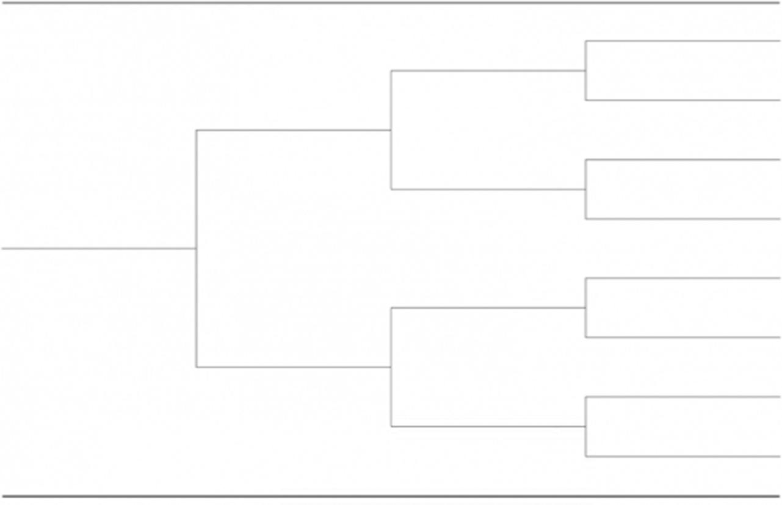
DOGS NSW Code of Practice-Record Keeping Information Booklet Pedigree Chart
Issued December 2019 (Amended June2020)

PUPPY/ADULT DOG HEALTH CERTIFICATE

To assist members with transparency in rehoming of healthy puppies/adult dogs.
If you or your Vet have an alternate form you prefer, please continue to use that.
NOTE: It is important to record all matters that are not within normal health parameters, eg, heart murmur, hernia, undescended testicle(s), etc.
DOGS NSW Code of Practice-Record Keeping Information Booklet Puppy/Adult Dog Health Certificate
Issued December 2019 (Amended January 2021)

PUPPY/ADULT DOG HEALTH CHECK CERTIFICATE
Dog details
Registered Name |  | Date of Birth | / /
Microchip number |  | Gender
Breed |  | Colour

Physical Exam:
WEIGHT: TEMP: PULSE/RESP:
HYDRATION: E Adequate E Marginal E Inadequate
Comments
TESTICLES: E 2 descended E 1 descended (L/R) E None descended E N/A
Comments
HERNIA: E No E Yes
Comments
DOGS NSW Code of Practice-Record Keeping Information Booklet Puppy/Adult Dog Health Check Certificate
Issued December 2019 (Amended January 2021)

MOUTH: ❑ Normal (Scissor Bite) ❑ Level Bite ❑ Overbite ❑ Underbite ❑ Other
Comments
EYES: ❑ Normal ❑ Conjunctivitis ❑ Glaucoma ❑ Cataracts ❑ Other
Comments
SKIN: ❑ Normal ❑ Hot Spots ❑ Fleas ❑ Mites ❑ Growth/Cyst ❑ Other
Comments
EARS: ❑ Normal ❑ Yeast ❑ Mites ❑ Other
Comments
CARDIOVASCULAR: ❑ Normal ❑ Murmur ❑ Arrhythmia ❑ Other
Comments
DOGS NSW Code of Practice-Record Keeping Information Booklet Puppy/Adult Dog Health Check Certificate
Issued December 2019 (Amended January 2021)

RESPIRATORY: E Normal E Infection E Other
Comments
LYMPH NODES: E Normal E Other
Comments
MUSCULOSKELETAL: E Normal E Other
Comments
GENITOURINARY: E Normal E Other
Comments
GASTROINTESTINAL: E Normal E Other
Comments
DOGS NSW Code of Practice-Record Keeping Information Booklet Puppy/Adult Dog Health Check Certificate
Issued December 2019 (Amended January 2021)

OVERALL HEALTH CONDITION: E Excellent E Good E Fair E Poor
Comments
Veterinarian’s Name (please print)
Veterinarian’s Signature (please sign)
Date:
Clinic Name:
Phone:
Clinic Address:
Web:
DOGS NSW Code of Practice-Record Keeping Information Booklet Puppy/Adult Dog Health Check Certificate
Issued December 2019 (Amended January 2021)

BREEDING CLEARANCE

To assist members with compliance with:-
- DOGS NSW Regulations Part XIII-Code of Ethics, Clauses 8, 9 and 12
- Animal Welfare Code of Practice for Breeding Dogs and Cats, Section 10
If you or your Vet have an alternate certificate, you can continue to use it in place of this sample template.

DOGS NSW Code of Practice-Record Keeping Information Booklet Breeding Clearance
Issued December 2019 (Amended January 2021)

BREEDING CLEARANCE CERTIFICATE
Bitch details
Registered Name |  | Date of Birth
Microchip number |  | Gender | Female
Breed |  | Colour

Veterinary Practitioner’s name
Practice: Name & Address
Contact Number
DOGS NSW Member’s Name
ANKC Ltd Registered Prefix
DOGS NSW Membership Number
Declaration
I , today examined the bitch identified above
being years of age and, in my opinion, there are no impediments to this animal being used for breeding.
Signed:
Date:
Comments

DOGS NSW Code of Practice-Record Keeping Information Booklet Breeding Clearance Certificate
Issued December 2019 (Amended January 2021)

IN CASE OF EMERGENCY
Contact Details for the Care of my Dog(s) at Home
Full Name (owner):
Address:
Contact number:
My Dog’s Name:
Microchip Number:
(Breed, likes, dislikes, age, distinguishing markings) medical conditions, neutered etc)
In an emergency please contact the following:-
1.
2.
3.
Please ensure that at no point should the above-named dog be surrendered to any party other than those named.
Signed
[Place photo of dog here]

DOGS NSW Code of Practice-Record Keeping Information Booklet Breeding Clearance Certificate
Issued December 2019 (Amended January 2021)

